Centripetal Acceleration
on a Turntable
As a child, you may remember the challenge of spinning a playground merry-go-round so you could scare the unfortunate riders as they traveled around a circular path. You worked especially hard to push the merry-go-round to increase its angular velocity. As the angular velocity of the riders increased, so did their centripetal acceleration. The challenge for the riders was to compete with the centripetal acceleration to maintain their grip—and their stomachs. The faster the merry-go-round was spun, the more difficult it became to stay on the ride. It may have disappointed you when the riders cheated and moved toward the center of the merry-go-round to reduce the acceleration. In this activity, you will investigate centripetal acceleration on a turntable. You will use a Low-g Accelerometer or Wireless Dynamics Sensor System (WDSS) attached to the turntable to determine the relationship between centripetal acceleration, angular velocity, and the radius of the circular path.
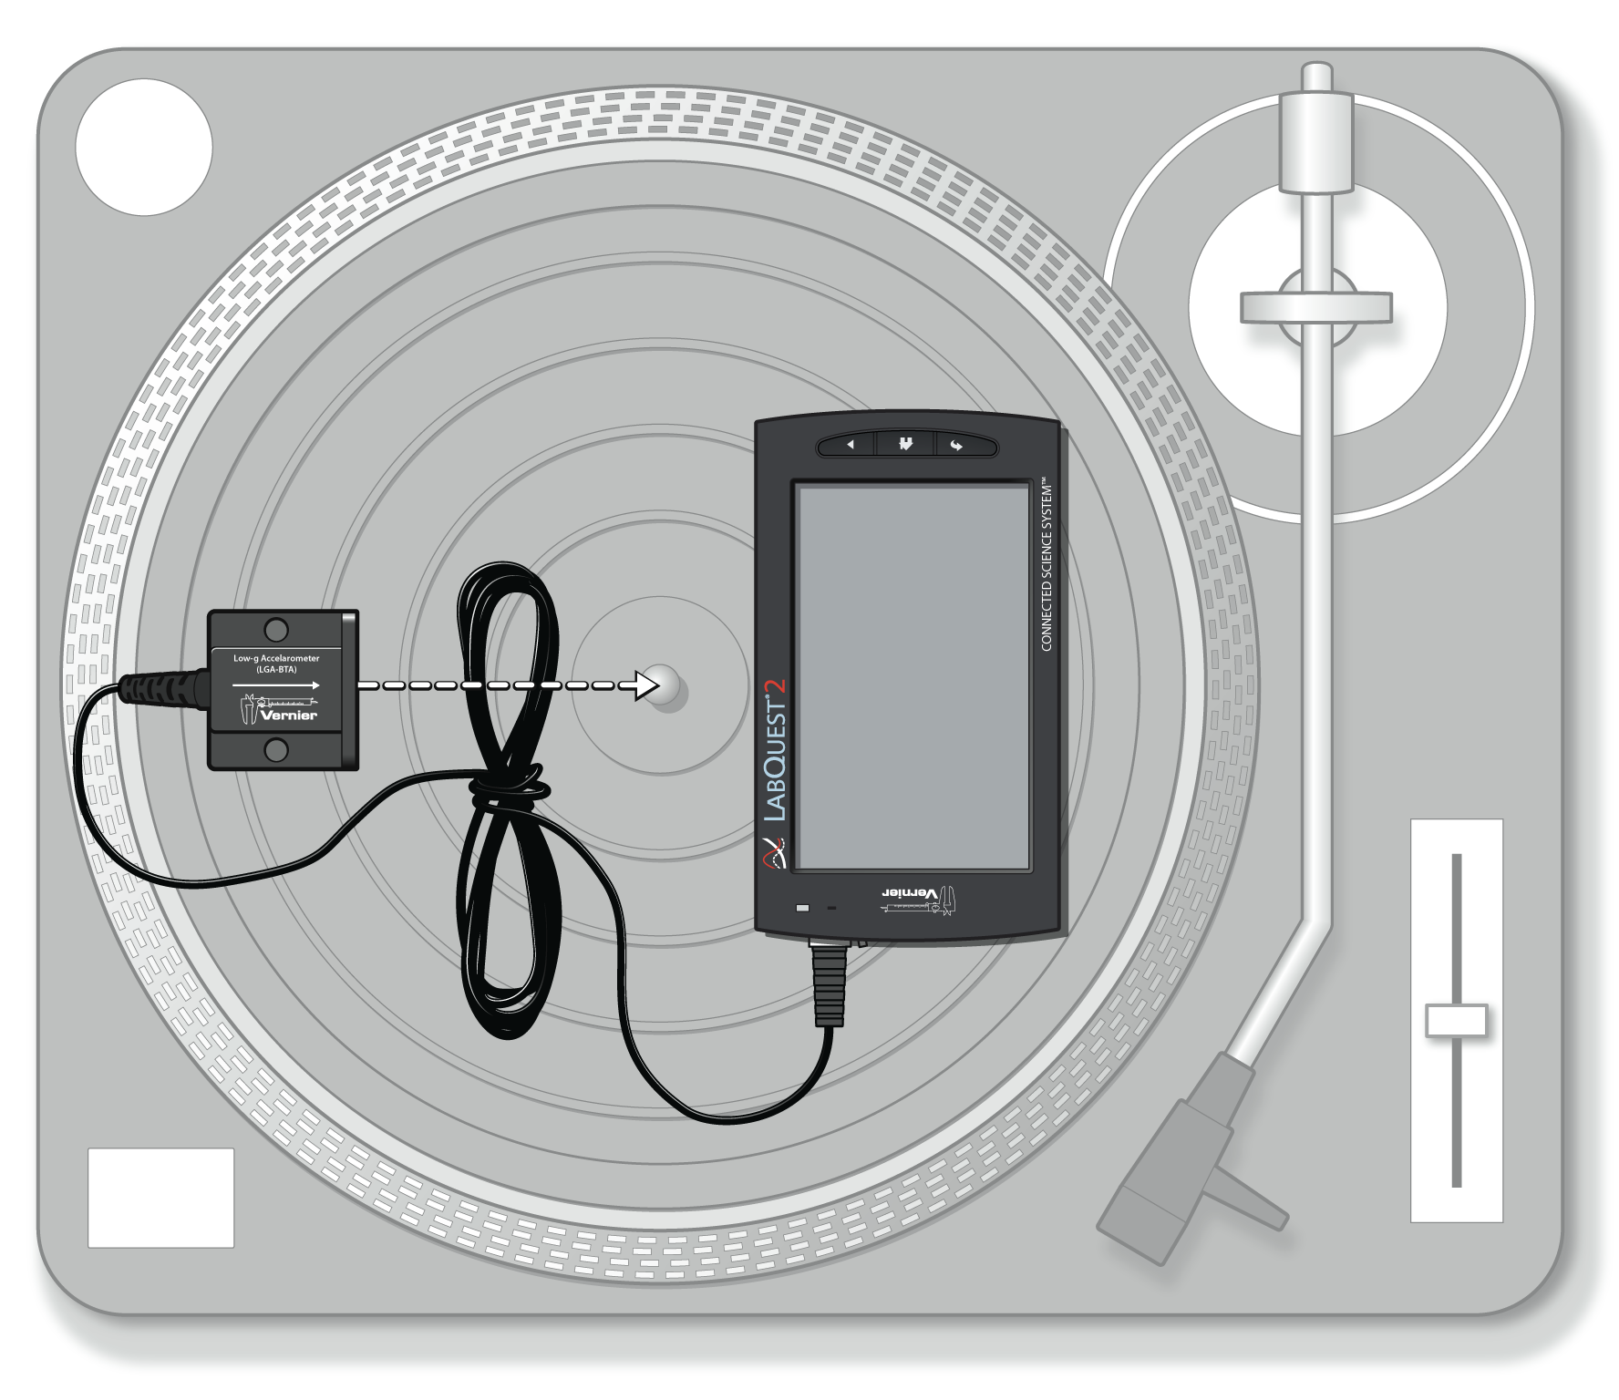
Figure 1

objectives
- Measure centripetal acceleration on a turntable.
- Determine the relationship between centripetal acceleration, radius, and angular velocity.
- Determine the direction of centripetal acceleration.

Materials
LabQuest | masking tape
LabQuest App | meter stick
Vernier Low-g Accelerometer | 20 g slotted mass
or Wireless Dynamics Sensor System (WDSS) | level
turntable with 33 1/3 and 45 rpm settings
(78 rpm is optional)

Preliminary questions
1. Place a 20 g mass about 5 cm from the center of the turntable. Set the turntable to run at 33 1/3 rpm, and turn it on. Observe the motion of the mass. Is the speed of the mass constant or changing? Is the velocity of the mass constant or changing? Using your last answer, is the acceleration of the mass constant, zero, or changing? If the acceleration is not zero, what is its direction?
2. Place a 20 g mass 5 cm from the center of the turntable. Set the angular velocity to 33 1/3 rpm and turn on the turntable. After a few rotations, switch to 45 rpm. Is the mass now undergoing less, the same, or more acceleration? Propose a mathematical relationship between centripetal acceleration and angular velocity.

PROCEDURE: Using a Low-g Accelerometer
1. Connect the Low-g Accelerometer to LabQuest and choose New from the File menu.
2. Set up LabQuest for data collection.
- On the Meter screen, tap Rate. Change the data-collection rate to 10 samples/second.
- Change the data-collection duration to 90 seconds. Select OK.

3. Zero the Low-g Accelerometer so that it reads zero when it is horizontal and the turntable is not moving.
- Rest the Low-g Accelerometer on a table with the arrow level and horizontal.
- Choose Zero from the Sensors menu. When the process is complete, the readings for the sensor should be close to zero.

Part I
What is the direction of the centripetal acceleration? To answer this question, you will need to understand the measurements of your Low-g Accelerometer. In particular, what direction, relative to the arrow on the Low-g Accelerometer, corresponds to a positive measurement? In this section, you will determine how to interpret the sign of your acceleration measurements by moving the Low-g Accelerometer through a known acceleration direction.
4. For motion along a line, does speeding up while moving in the positive direction correspond to a positive or a negative acceleration? Does slowing down while moving in the positive direction correspond to a positive or a negative acceleration? Answer based on the definitions of position, velocity, and acceleration. Record your answers in the data table.
5. Rest the Low-g Accelerometer on a smooth tabletop so that the arrow is horizontal and pointing to your right. Start data collection. Start with the Low-g Accelerometer at rest. Without tilting it, sharply move the Low-g Accelerometer in the direction of the arrow for about 30 cm and stop. In other words, make the Low-g Accelerometer start from rest, speed up, and then slow down, finally stopping. All motion must be along the line of the arrow.
6. Inspect your graph of acceleration vs. time. Since the Low-g Accelerometer had to speed up in the direction of the arrow before later slowing down, is an acceleration in the direction of the arrow read as positive or negative? Use the graph to guide your conclusion. Record your result in the data table.

Part II
7. Set up the turntable.
- Place the turntable on a level surface. Use the level to check that the turntable platter is level. Make any necessary adjustments.
- Tape the LabQuest to the turntable platter as shown in Figure 1.
- Tape the Low-g Accelerometer to the platter near the outer edge, with the arrow aligned to the center of the turntable, as shown in Figure 1.
- Measure the distance from the center of the turntable to the edge of the Low-g Accelerometer, at the midline, as indicated by the dashed line in Figure 1. Add to this value the distance from the edge of the Low-g Accelerometer to the accelerometer transducer within the case, 0.762 cm. The resulting value is the distance from the center of the turntable to the transducer. Record this radius in the data table.

8. You are now ready to collect centripetal acceleration data for at least two different angular velocities.
- Verify that the Low-g Accelerometer, LabQuest, and cable are taped down so that nothing will get hung up when the turntable spins.
- Set the turntable speed to 33 1/3 rpm.
- Start data collection. Wait 20 seconds.
- Turn on the turntable, letting it rotate at 33 1/3 rpm.
- Wait about 20 seconds and increase the speed to 45 rpm.
- If your turntable has a 78 rpm setting, wait another 20 seconds and increase the speed to 78 rpm.
- After another 20 seconds turn off the turntable, allowing it to slow to a stop.

9. When data collection is complete, a graph of acceleration vs. time is displayed. To examine the displayed graph, tap any data point. Acceleration and time values are displayed to the right of the graph.
10. Next, determine the average centripetal acceleration for each angular velocity.
- Tap and drag across the region that represents the time when the turntable was rotating at 33 1/3 rpm to select the region.
- Choose Statistics from the Analyze menu. Record the value of the mean acceleration, including the algebraic sign, in the data table.
- Choose Statistics from the Analyze menu to turn off statistics.

11. Repeat Step 10 for the 45 rpm portion of the graph and record the value in your data table. If you also collected data at 78 rpm, repeat Step 10 for the 78 rpm portion of the graph.
Part III
For this part, you will see how centripetal acceleration varies with radius by taking data at varying radii while keeping the angular velocity constant at 45 rpm. The 45 rpm point from Part II will serve as your first data point for this part.
12. Copy your acceleration and radius values for 45 rpm from Part II to the first line of the data table for Part III.
13. Adjust the position of the Low-g Accelerometer.
- Move the Low-g Accelerometer about 3 cm inward toward the center of the turntable. Fasten it securely with the arrow pointing directly toward the center of the turntable, as shown in Figure 1.
- Measure the distance from the center of the turntable to the edge of the Low-g Accelerometer, at the midline, as indicated by the dashed line on Figure 1. Add to this value the distance from the edge of the Low-g Accelerometer to the accelerometer transducer, 0.762 cm. The resulting value is the distance from the center of the turntable to the transducer. Record this radius in the data table.

14. Set the turntable speed to 45 rpm.
15. Prepare to collect acceleration data at various radii. To do this, you need to shorten the duration of data collection.
- Tap Meter.
- On the Meter screen, tap Duration. Change the data-collection duration to 30 seconds. Select OK.

16. Collect acceleration data.
- Verify that the LabQuest, Low-g Accelerometer, and cable are taped down so that nothing will get hung up when the turntable spins.
- Start data collection. Wait 5 seconds, and then turn on the turntable.
- Wait at least 25 seconds and turn off the turntable.

17. When data collection is complete, a graph of acceleration vs. time is displayed. Examine the displayed graph and determine the average centripetal acceleration.
- Tap and drag across the region that represents the time when the turntable was rotating.
- Choose Statistics from the Analyze menu. Record the value of the mean acceleration, including the algebraic sign, in the data table.
- Tap Meter.

18. Move the Low-g Accelerometer inward about 3 cm and tape it to the turntable with the arrow pointed toward the center. Repeat Steps 16–17 to collect data at the new radius.

Data Table
Part I
Speeding up in + direction
Slowing down in + direction
Acceleration in direction of arrow reads

Part II
Radius (m)

Angular speed |  | Centripetal acceleration (m/s²)
(rpm) | (rad/s) | Centripetal acceleration (m/s²)
33 ¹/₃
45
78 (optional)

Part III
Angular speed |  |  | Radius (m) | Centripetal acceleration (m/s²)
(rpm) | (rad/s) |  | Radius (m) | Centripetal acceleration (m/s²)
45
45

Analysis
1. Convert angular speed values from rpm (revolutions per minute) to radians per second. Record the new values in the data table. Note: One revolution corresponds to 2π radians.
2. Use LabQuest, Logger Pro, or graph paper to plot a graph of the centripetal acceleration data collected in Part II vs. the square of angular speed.
3. Fit a straight line that passes through the origin to your data points. What are the units of the slope? Does this value correspond to any dimension on your apparatus?
4. Use LabQuest, Logger Pro or graph paper to plot a graph of the centripetal acceleration data collected in Part III vs. the radius.
5. Fit a straight line that passes through the origin to your data points. What are the units of the slope? Does this value correspond to any parameter in your experiment? Note that rad/s and 1/s have the same dimensions, since the radian is dimensionless. Does the slope value correspond to any parameter in your experiment? How about the square root of the slope?
6. From your graphs, propose a relationship between centripetal acceleration, the square of angular velocity, and radius. Verify that the relationship is dimensionally consistent.
7. Look up the relationship for centripetal acceleration to confirm your proposal.
8. What was the sign of the centripetal acceleration as measured by the accelerometer? Given the sign your accelerometer reads when accelerating in the direction of the arrow, is the centripetal acceleration directed inward or outward?

