Atwood’s Machine
A classic experiment in physics is the Atwood’s machine: two masses on either side of a pulley connected by a light string. When released, the heavier mass accelerates downward while the lighter one accelerates upward at the same rate. The acceleration depends on the difference in the two masses, as well as the total mass.
In this lab, you will determine the relationship between the two factors that influence the acceleration of an Atwood’s machine using a Photogate to record the machine’s motion.
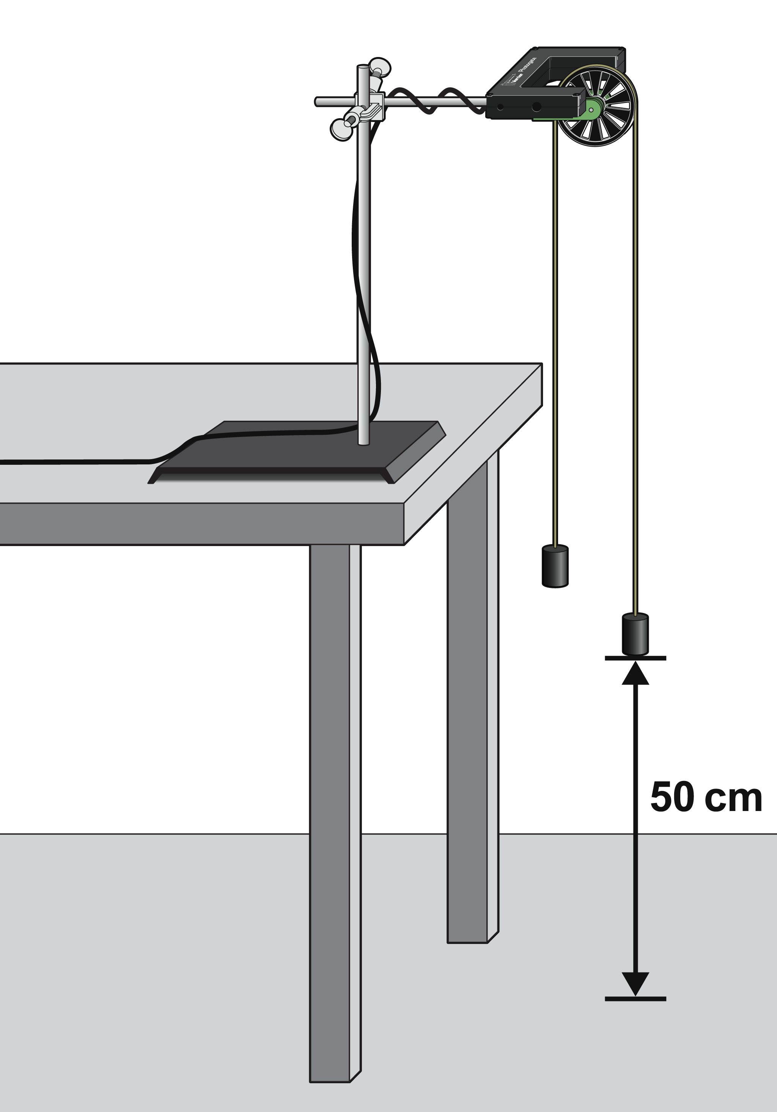
Figure 1

Objectives
- Use a Photogate to study the acceleration of an Atwood’s machine.
- Determine the relationships between the masses on an Atwood’s machine and the acceleration.

Materials
LabQuest  Ultra Pulley Attachment | 2 - 100 g masses  12 – 7 g washers
Vernier Photogate  2 Paperclips | string,1.2 m long
Preliminary Questions
1. If two objects of equal mass are suspended from either end of a string passing over a light pulley, as in Figure 1, what kind of motion do you expect to occur? Why?
2. Draw a free-body diagram of the left-side mass in Figure 1. Draw another of the right-side mass. Include all forces acting on each mass.
3. Do the two masses have the same acceleration? Why?
4. How would you expect the acceleration of an Atwood’s machine to change if you
- Increase the mass on one side and decrease the mass on the other, keeping the total mass constant?
- Gradually increase the mass of both sides, keeping the difference in mass constant?

Procedure
Part I Constant Total Mass
For this part of the experiment you will keep the total mass used constant, but move weights from one side to the other.
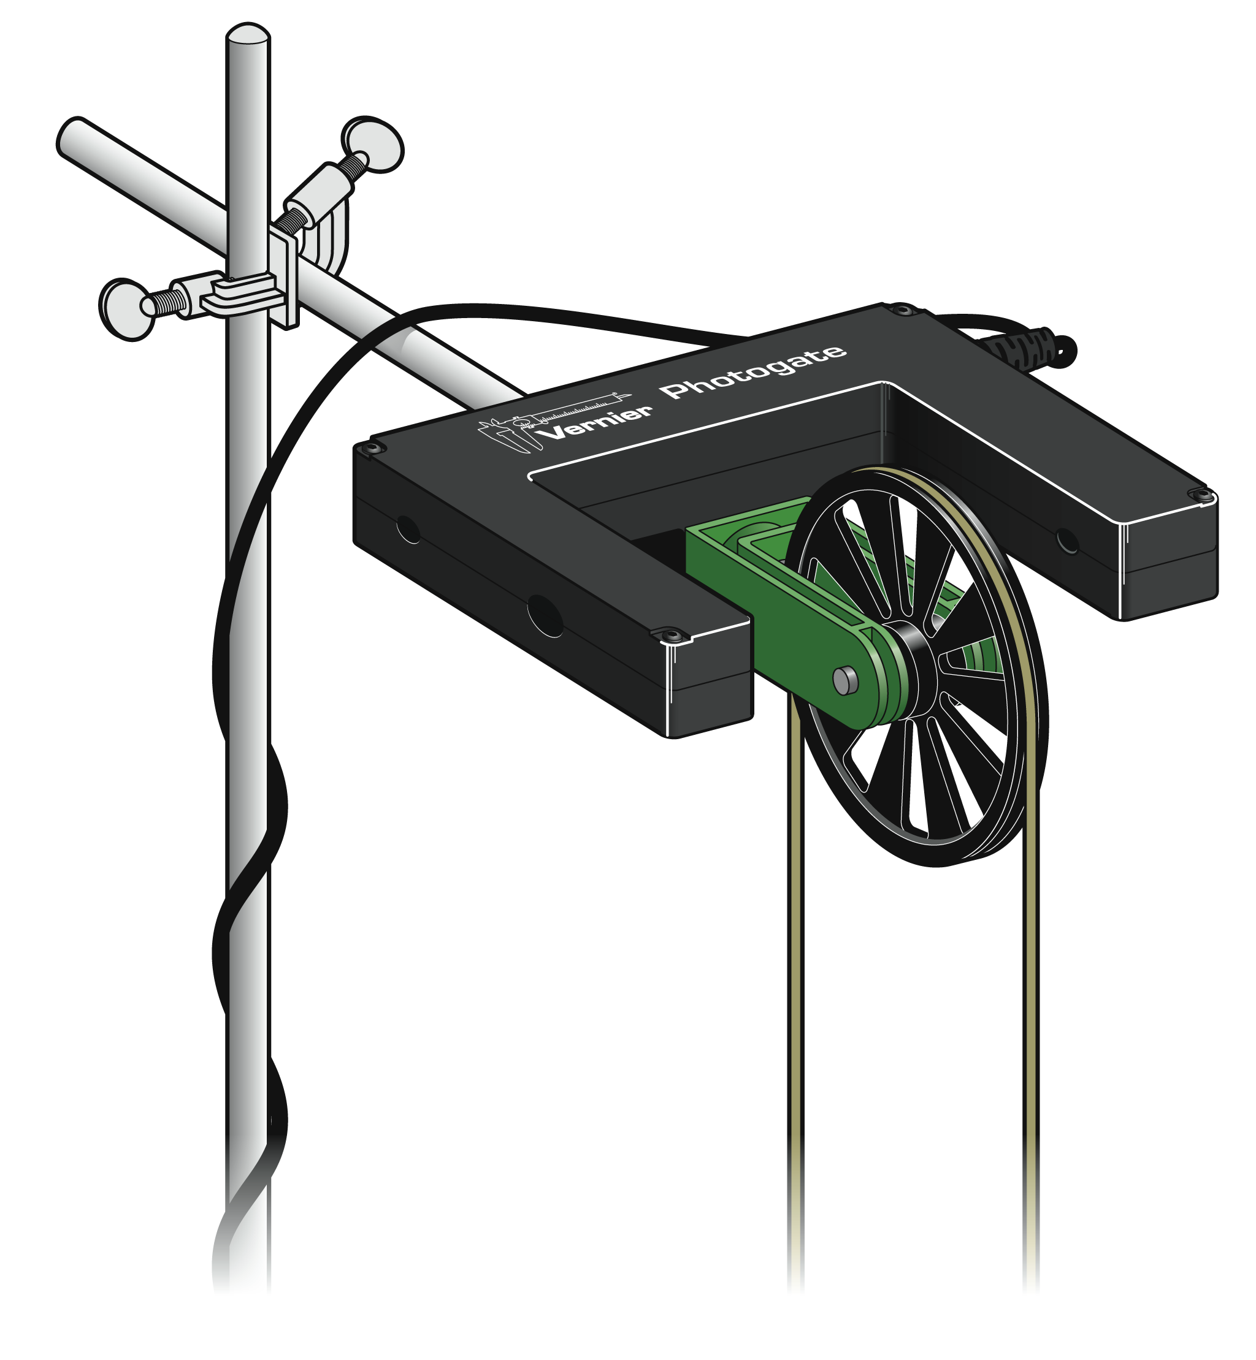
1. Set up the Atwood’s machine apparatus as shown in Figures 1 and 2. Note: The masses must be able to move at least 40 cm before the heavier mass strikes the floor.
Figure 2
2. Connect the Photogate with Ultra Pulley to a digital (DIG) port of LabQuest and choose New from the File menu.
3. Set up LabQuest for a pulley with a string that runs in a groove.
- On the Meter screen, tap Mode.
- Select Pulley (10 spoke) in groove.
- Select OK.

4. Arrange a collection of masses on m2 and on m1. Use one 100 g mass and 6 identical washers on each side. What is the acceleration of this combination? Record your values for mass and acceleration in the data table.
5. Move one washer from m2 to m1. Record the new masses in the data table.
6. To measure the acceleration of this system, start with the masses even with each other. Steady the masses so they are not swinging. Start data collection. After a moment, release the smaller mass, catching the falling mass before it strikes the floor or the other mass strikes the pulley.
7. Display only the velocity vs. time graph by choosing Show Graph ► Graph 2 from the Graph menu. Examine the graph. The slope represents the acceleration of the masses.
8. Fit a straight line to the velocity vs. time graph.
- Choose Curve Fit from the Analyze menu.
- Select Linear as the Fit Equation.
- Record the slope of the linear curve fit (acceleration) in the data table and then select OK.
9. Continue to move washers from m₂ to m₁ in 7 g increments, changing the difference between the masses, but keeping the total constant. Repeat Steps 6–8 for each mass combination. Continue until you collect data for at least five different mass combinations.
Part II Constant Mass Difference
For this part of the experiment you will keep the difference in mass between the two sides of the Atwood’s machine constant and increase the total mass.
10. Use 100 g plus 2 washers for m₁ and 100 g for m₂.
11. Repeat Steps 6–8 to collect data and determine the acceleration.
12. Add mass in 1 washer, 7 g increments, to both sides keeping a constant difference of 2 washers. Record the resulting mass for each combination in the data table. Collect motion data and determine the acceleration for at least five different mass combinations.

Data Table
Part I Constant Total Mass
Trial | m₁  (g) | m₂  (g) | Acceleration  (m/s²) | m_{diff},  m₁–m₂  (g) | m_{T}  (g)
1
2
3
4
5

Part II Constant Mass Difference
Trial | m₁  (g) | m₂  (g) | Acceleration  (m/s²) | m_{diff},  m₁–m₂  (g) | m_{T}  (g)
1
2
3
4
5

Analysis
1. For each trial, calculate the difference between m₁ and m₂. Enter the result in the column labeled m_{diff}.
2. For each trial, calculate the total mass in grams. Enter the result in the column labeled m_{T}.
3. Using LabQuest, Logger Pro, or graph paper, plot a graph of acceleration vs. m_{diff}, using the Part I data. Based on your analysis of the graph, what is the relationship between the mass difference and the acceleration of an Atwood’s machine?
4. Similarly, plot a graph of acceleration vs. m_{T}, using the Part II data. Based on your analysis, what is the relationship between total mass and the acceleration of an Atwood’s machine?
5. Develop a single expression for the acceleration of an Atwood’s machine, combining the results of the previous two steps in the analysis.

Extensions
1. For one of the experimental runs you made, calculate the expected acceleration using the expression you found with Newton’s second law of motion and the specific masses used. Compare these figures with your experimental results in another data table. Are the experimental acceleration values low or high? Why?
2. An unknown mass can be placed on one side of the Atwood’s machine. Using lab measurements and any necessary calculations, the mass of the unknown can be determined. Try it. Show your calculations and the data collected.

