Speed of Sound
Compared to most things you study in the physics lab, sound waves travel very fast. It is fast enough that measuring the speed of sound is a technical challenge. One method you could use would be to time an echo. For example, if you were in an open field with a large building a quarter of a kilometer away, you could start a stopwatch when a loud noise was made and stop it when you heard the echo. You could then calculate the speed of sound.
To use the same technique over short distances, you need a faster timing system, such as a data-collection interface. In this experiment, you will use this technique with a Microphone connected to an interface to determine the speed of sound at room temperature. The Microphone will be placed next to the opening of a hollow tube. When you make a sound by snapping your fingers next to the opening, the computer will begin collecting data. After the sound reflects off the opposite end of the tube, a graph will be displayed showing the initial sound and the echo. You will then be able to determine the round trip time and calculate the speed of sound.
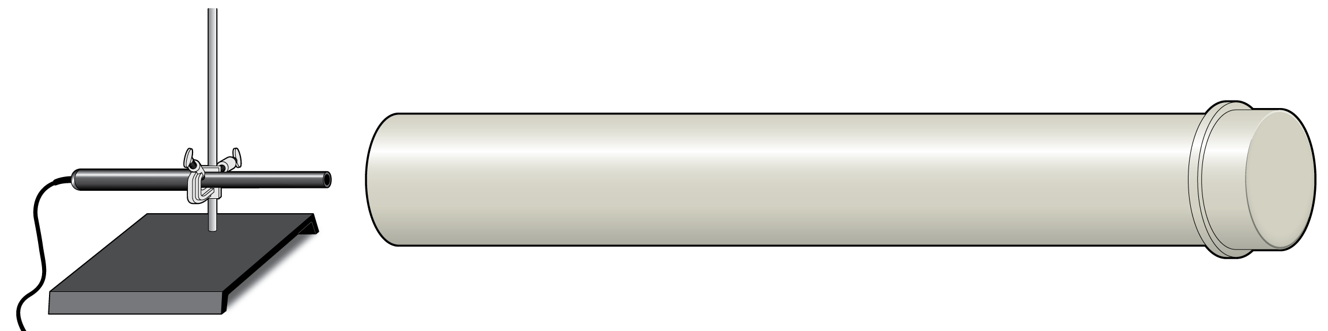
Figure 1

OBJECTIVES
- Measure how long it takes sound to travel down and back in a long tube.
- Determine the speed of sound.
- Compare the speed of sound in air to the accepted value.

MATERIALS
LabQuest | tube, 1–2 meters long
LabQuest App
Vernier Microphone | meter stick or tape measure
thermometer or Vernier Temperature Probe | (optional) dog training clicker

PRELIMINARY QUESTION
- How fast is sound? Does it seem to be instantaneous? Refer to your own experience as a basis for your answer.

- What is an echo? When you hear an echo, is there a delay between making a sound and hearing the echo? Why do you think that is?

PROCEDURE
1. Use the thermometer or Temperature Probe to measure the air temperature of the classroom.
2. Record the room temperature in your data table.
3. Connect the Microphone to LabQuest. Choose New from the File menu.
4. Set up the interface to trigger on the first loud sound the Microphone detects.
- Select Zero from the Sensors menu.
- On the Meter screen, tap Mode.
- Select Triggering and select Enable Triggering.
- Change the Triggering settings so that data collection starts when voltage is increasing across 0.1. Collect 0 points before trigger. Then select OK.

5. Close the end of the tube. This can be done by putting on a cap or standing a book against the end so it is sealed. Measure the length of the tube and record in the data table.
6. Place the Microphone as close to the end of the long tube as possible, as shown in Figure 1. Position the Microphone so that it can detect the initial sound and the echo coming back down the tube.

7. Start data collection. Click the dog training clicker near the opening of the tube. This sharp sound will trigger the interface to begin collecting data.
8. If you are successful, the graph will resemble the one in Figure 2. You may not see a third reflection. The first peak is the initial sound, the second is the first reflection, and the third is a second reflection. Repeat data collection if necessary. Tap any data point on a graph to read the sound and time values displayed to the right of the graph. Determine the time interval between the start of the first vibration and the start of the echo vibration. Do this by choosing Delta ► Graph 1 from the Analyze menu. Tap and drag from the start of the sound to the start of the echo, as shown in Figure 2. In the data table, record the time interval displayed on the graph.
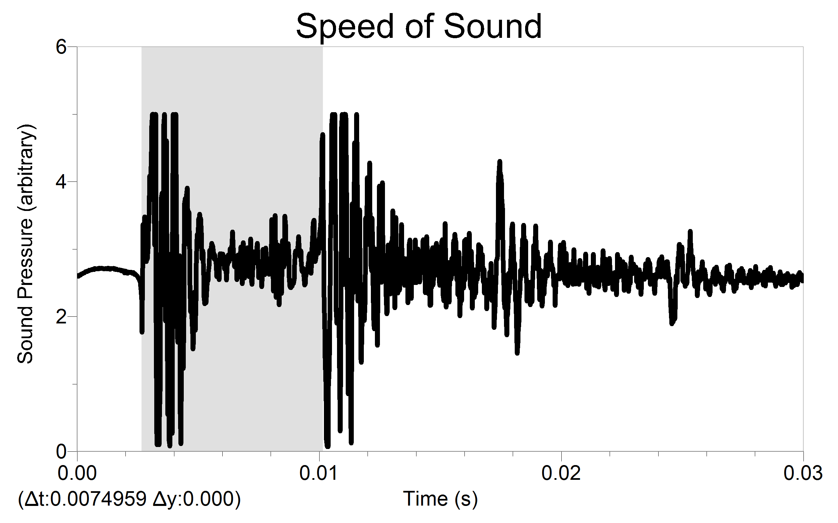
Figure 2

9. Repeat the measurement for a total of five trials.
DATA TABLE
Length of tube | m
Temperature of room | °C

Trial | Total travel time (s)
1
2
3
4
5
Average

Speed (m/s)

ANALYSIS
1. Calculate the average time interval between the sound and its echo using the time intervals in your data table.
2. Calculate the speed of sound. Remember that your average time interval represents the time for sound to travel down the tube and back.
3. The accepted speed of sound at atmospheric pressure and 0°C is 331.5 m/s. The speed of sound increases 0.607 m/s for every °C. Calculate the speed of sound at the temperature of your room and compare your measured value to the accepted value.
4. Repeat this experiment, but collect data using a tube with an open end. First predict if the data will be different than the closed end data. If you feel it will be different, describe the predicted differences.

Length of tube | m
Temperature of room | °C

Trial | Total travel time (s)
1
2
3
4
5
Average

Speed (m/s)

How do the reflected waves for the closed-end tube compare to the reflections with an open-end tube? Calculate the speed of sound and compare it to the results with a tube with a closed end. What could account for the differences in data? How do these data compare to your predictions?

